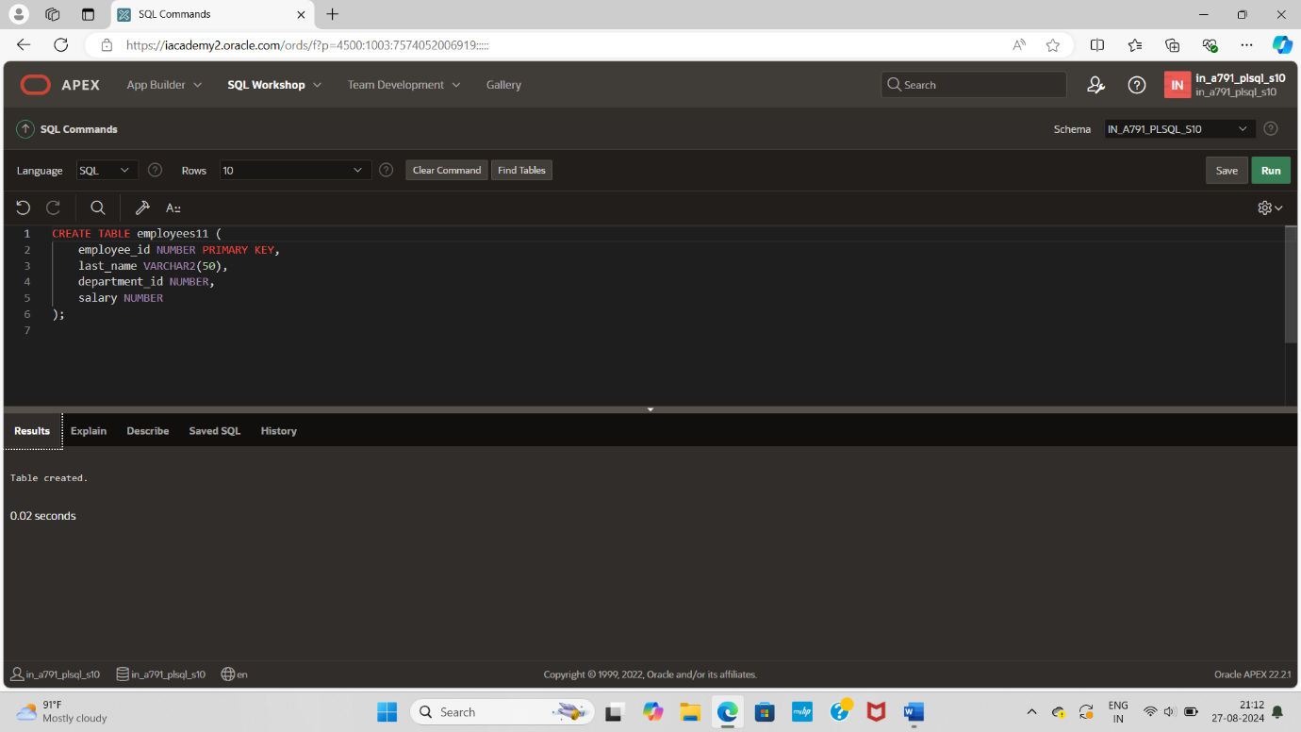

CREATE TABLE employees11 (

employee_id NUMBER PRIMARY KEY,

last_name VARCHAR2(50),

department_id NUMBER,

salary NUMBER

);

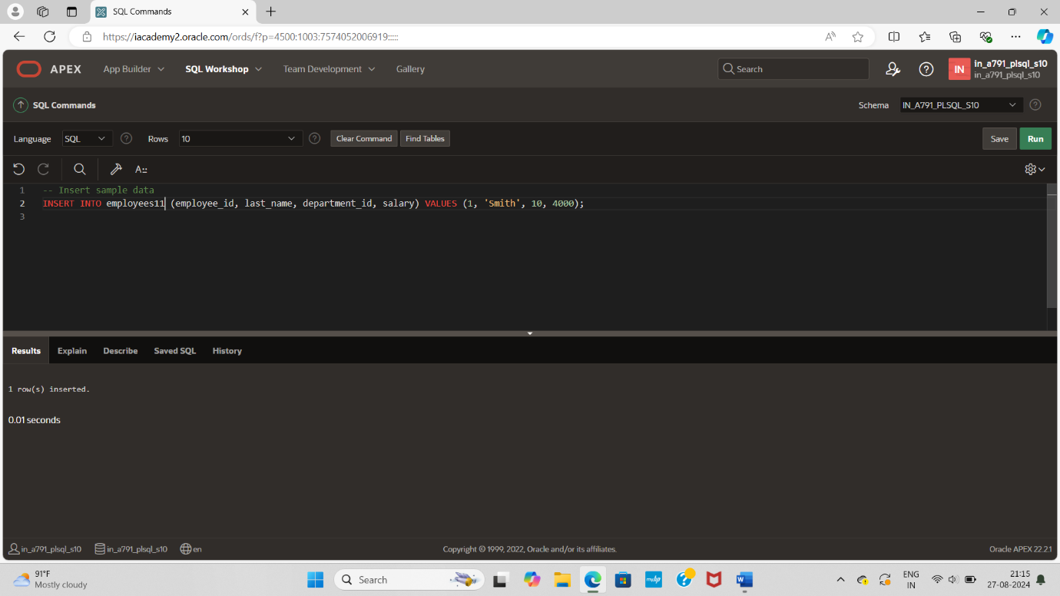

INSERT INTO employees11 (employee_id, last_name, department_id, salary) VALUES (1, 'Smith', 10, 4000);



INSERT INTO employees11 (employee_id, last_name, department_id, salary) VALUES (2, 'Johnson', 20, 5000);

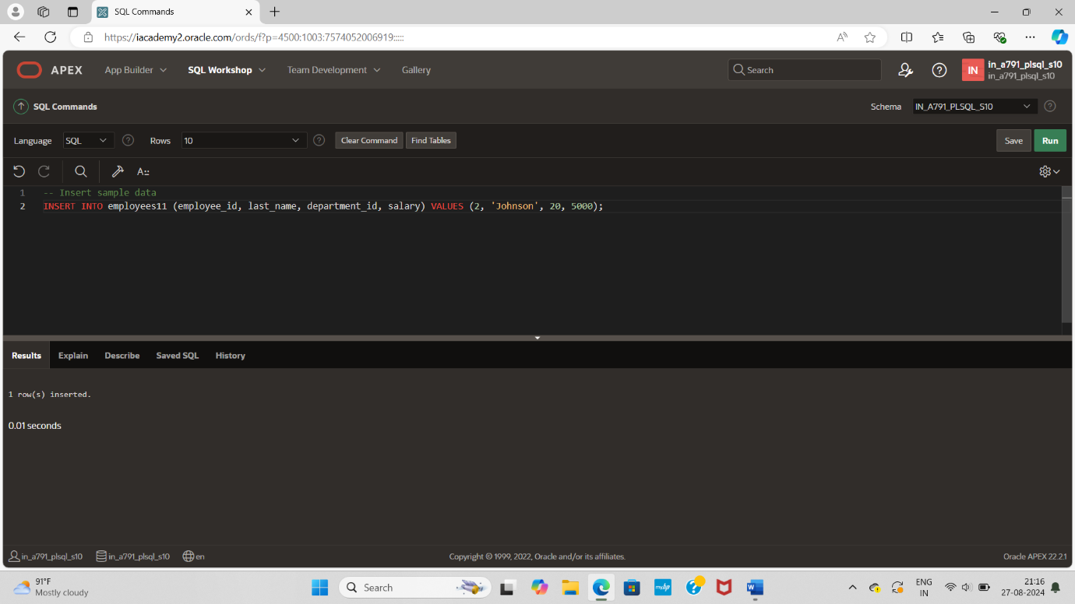

INSERT INTO employees11 (employee_id, last_name, department_id, salary) VALUES (3, 'Williams', 10, 4500);

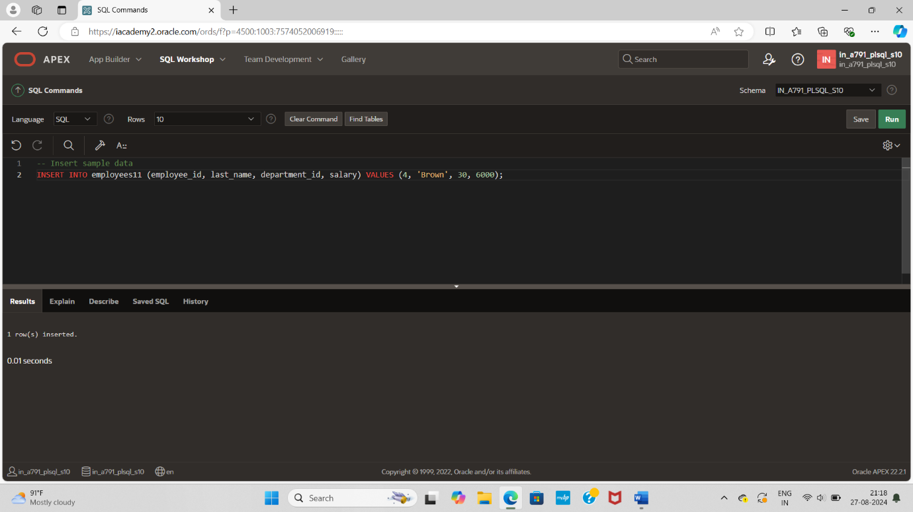

INSERT INTO employees11 (employee_id, last_name, department_id, salary) VALUES (4, 'Brown', 30, 6000);

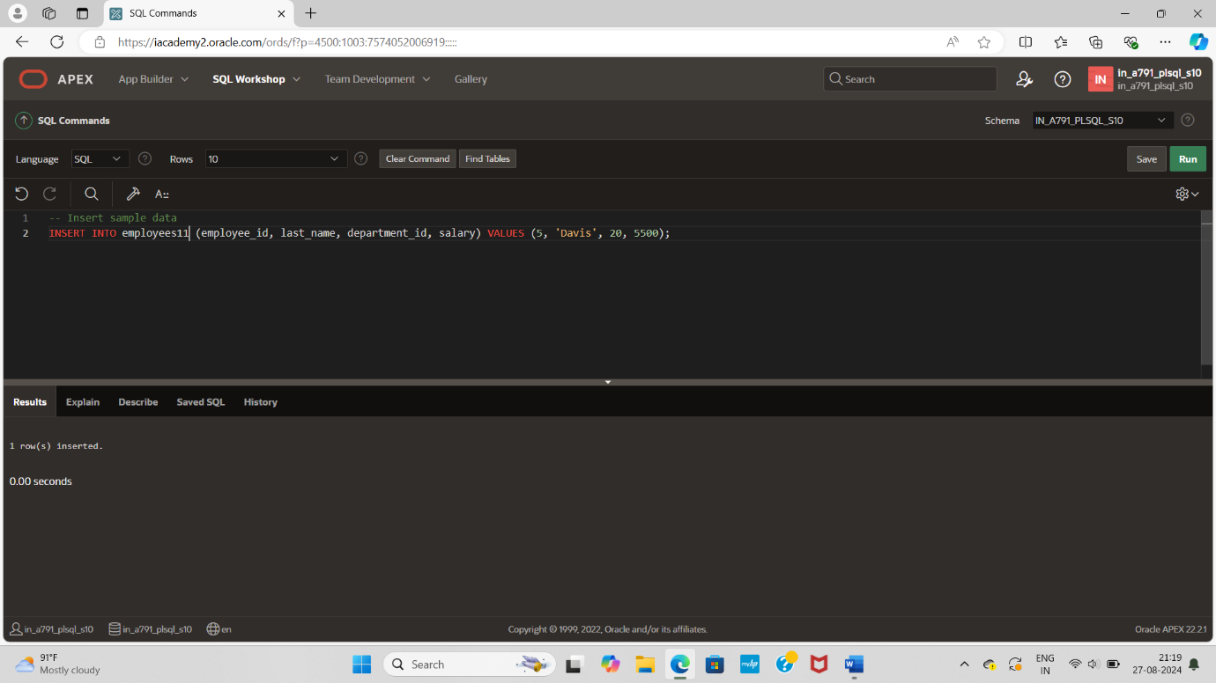

INSERT INTO employees11 (employee_id, last_name, department_id, salary) VALUES (5, 'Davis', 20, 5500);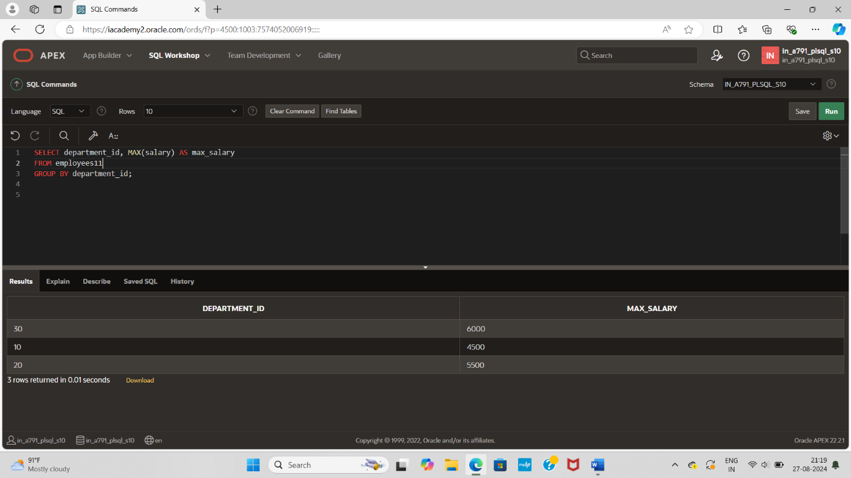

SELECT department_id, MAX(salary) AS max_salary

FROM employees11

GROUP BY department_id;